Reading and Discussion - Spring 2014 Syllabus
Instructor: Troy Rubesch
Place: E-CO classroom
Meeting times: Tues 4th (15:00) -or- Weds 5th (16:40) -or- Thurs 5th (16:40)
E-mail: e.co.otemon@gmail.com
E-CO phone number: 072-641-7328
Website: eco-otemon.org

Class focus: Reading & Discussion
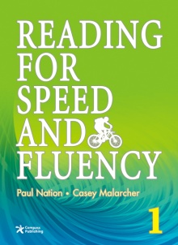
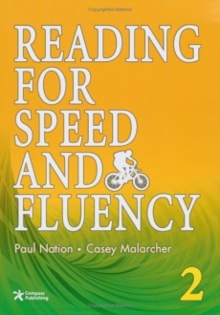
- Reading faster

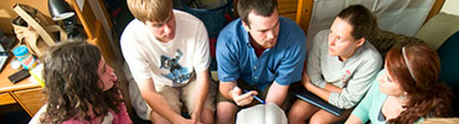
- Reading more

- (Writing)
- Discussion

In this class, students will:
- do a speed reading activity
- read an easy book each week- FINISH BEFORE CLASS
- write a reading journal each week- FINISH BEFORE CLASS
- discuss your journals in small groups
- do reading and test-taking activities


Class Rules: You are Responsible for Your Learning
- Do your homework before class
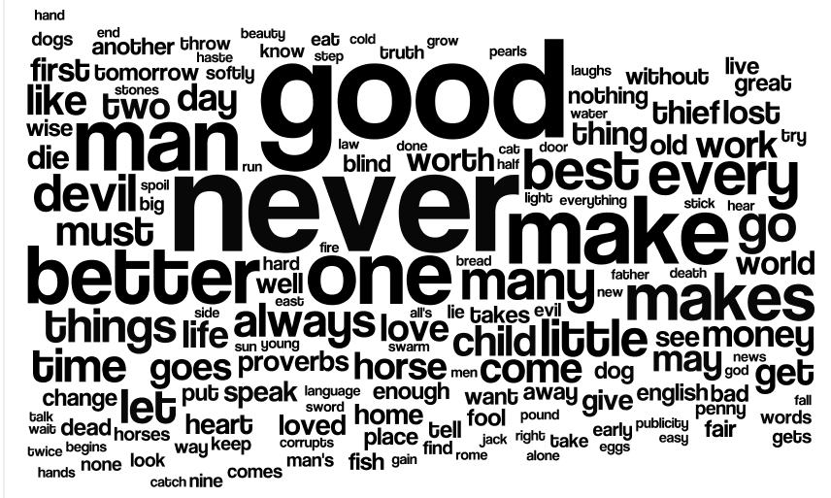

- Come to class on time
- Speak English
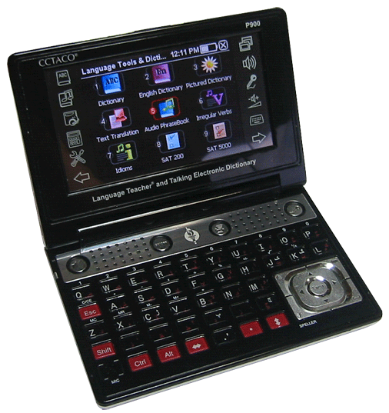
- Use your dictionary app
- Take notes
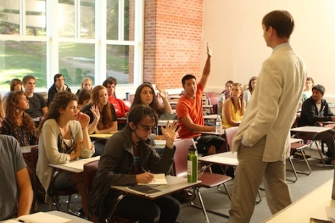
- Ask questions
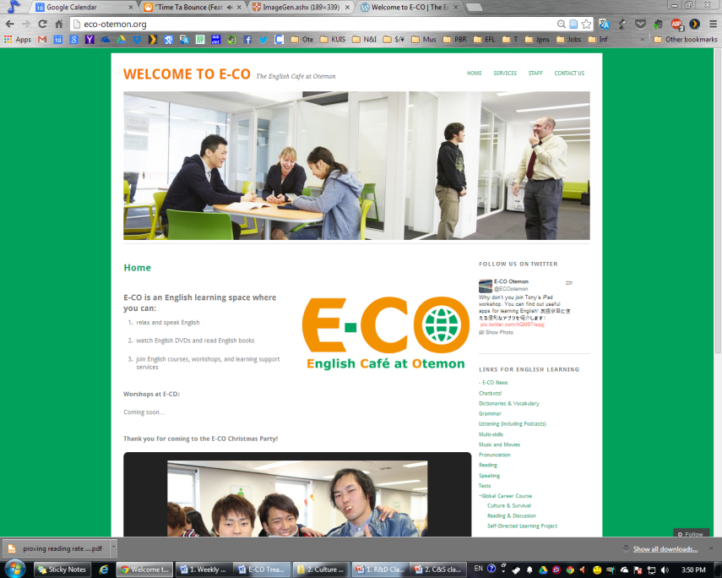
- If you are absent, do the homework at eco-otemon.org
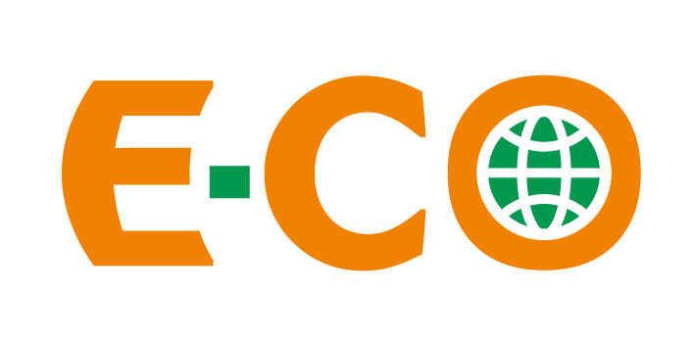
- Use E-CO

Materials: 1 B5-size 50-page lined notebook– bring to the next class

Evaluation
- Attendance 30%
- Participation 30%
- Journal 30%

- Poster Presentation 10%
I will report your grades to the Center for International Studies
(国際交流教育センター) two times each semester

